Galapagos Central Wonders Cruise

Itinerary C+A / 8 days – 7 nights

 |  |  |  | HIKING | SNORKEL | PANGA RIDE | PADDLE BOARD | KAYAK
8 DAYS  “CA” | SATURDAY | PM | Santa Cruz: Bachas Beach | • | •
 | SUNDAY | AM | Bartolome Island | • |  | •
 |  | PM | Santiago: Sullivan Bay | • | • | • | •
 | MONDAY | AM | Plazas: South Plazas | • | •
 |  | PM | Santa Fe Island | • | • | • | • | •
 | TUESDAY | AM | San Cristobal: Witch Hill | • | • | •
 |  | PM | San Cristobal: Pitt Point | • | •
 | WEDNESDAY | AM | San Cristobal: Highlands | • | • | • | • | •
 |  | PM | San Cristobal: Lobos Island | • | • | •
 | THURSDAY | AM | Española: Suarez Point | •
 |  | PM | Española: Gardner Bay | • | • | • | •
 | FRIDAY | AM | Floreana: Post Office Bay | • | •
 |  | PM | Floreana: Cormorant Point | • | • | • | • | •
 | SATURDAY | AM | Santa Cruz: Charles Darwin Station | •

Day 1 - Saturday

AM: ARRIVAL AT BALTRA AIRPORT
Your voyage to the captivating Galapagos Islands commences! Upon your arrival at Baltra Airport, you'll be greeted by our National Park-certified naturalist guide, ready to introduce you to the unique wonders of this pristine archipelago.
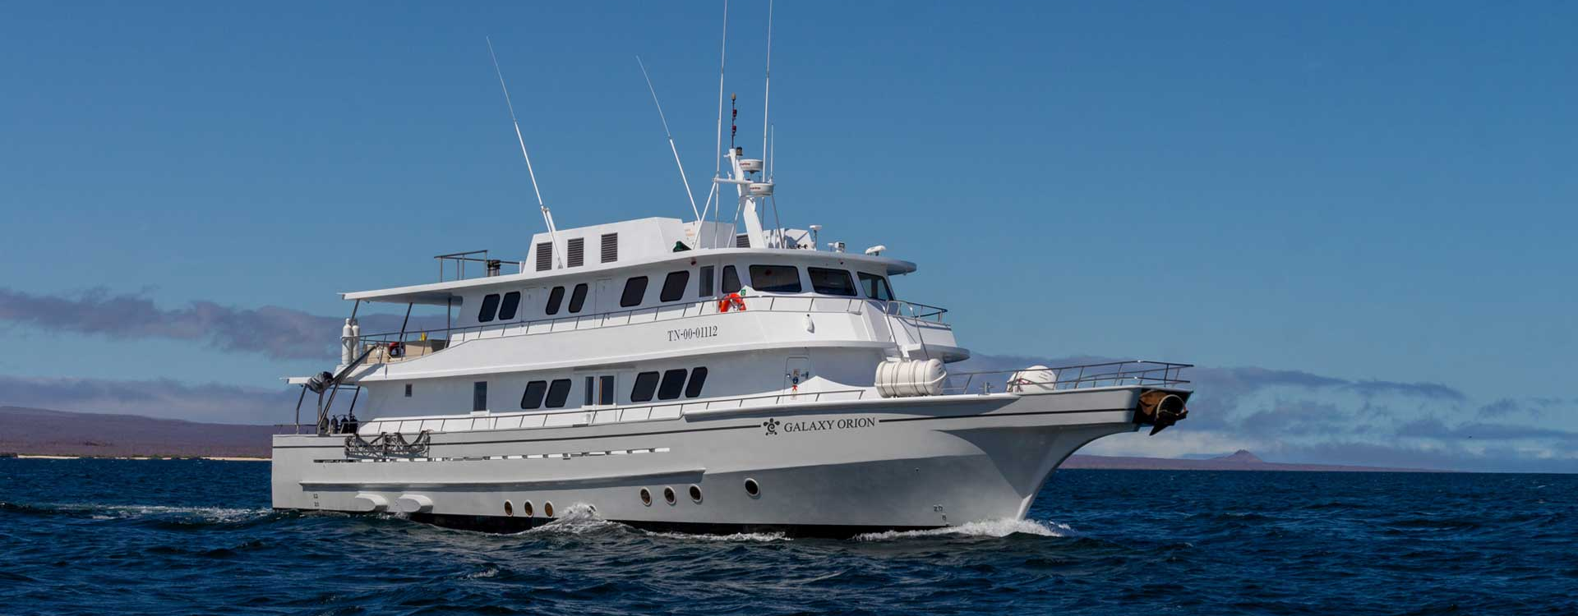

PM: BACHAS
Bachas, named after the mispronounced "barges" left by the Americans during WWII, begins your final day. At low tide, the iron skeletons of the barges can still be spotted buried in the white sand. This spot is one of the most crucial sea turtle nesting grounds in the Galapagos islands from November to May. Several small saltwater lagoons are often home to flamingoes, herons, and other aquatic birds.

Following your visit to Bachas, you will be transferred to the airport for your flight back to mainland Ecuador, concluding your unforgettable Galapagos journey.
Highlights: American flamingoes, white-cheeked pintails, sandpipers, lava gulls, and blue-footed boobies.
Meals | L / D
Trail | 1,6 km / 1 mi
Level | 1
Activities | Wet landing and hiking

Day 2 – Sunday

AM: BARTOLOME
Stand atop Bartolome Island for unparalleled views of the lunar-like landscape, punctuated by scattered volcanic cones, Pinnacle Rock, and the bay of Sullivan. Bartolome is a jewel in the Galapagos crown and home to a vibrant population of penguins.
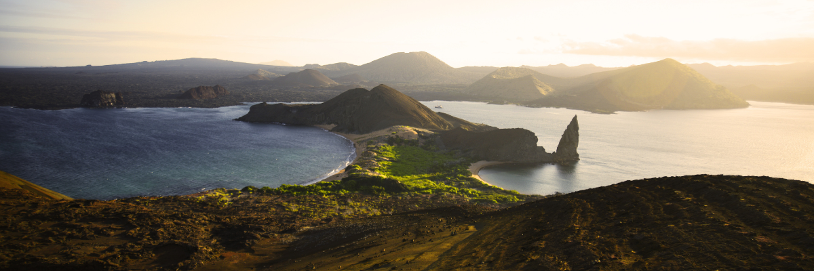
Snorkeling Experience: A swim or snorkel from the beach opens up an underwater playground renowned in the Galapagos. Penguins, a multitude of fish, colorful invertebrates, sea lions, turtles, rays, and reef sharks make this snorkeling experience unforgettable.
Highlights: Galapagos penguins, volcanic landscapes, Pinnacle rock, blue-footed boobies, herons, sea lions, sharks.
Trail | 1,5 km / 0,9 mi
Level | 2
Activities | Dry landing and hiking

AM: SULLIVAN BAY
Step back in time at Sullivan Bay, an open book to the volcanic birth of these islands. Traverse the well-preserved Pahoehoe lava field, studying its delicate, unique textures. The seemingly lifeless landscape gradually unveils a resilience of nature, with pioneer plants, lava lizards, and tiny birds emerging on careful observation. Keep your eyes on the shoreline for resident penguins, pelicans, and oystercatchers.
Snorkeling Experience: A dip in the water here starkly contrasts the barren land. The coral sand beach and the dinghy access point reveal a marine world with fish schools, Galapagos penguins, reef sharks, turtles, and rays.
Highlights: Pahoehoe lava, Galapagos penguins, oystercatchers, Galapagos hawks.
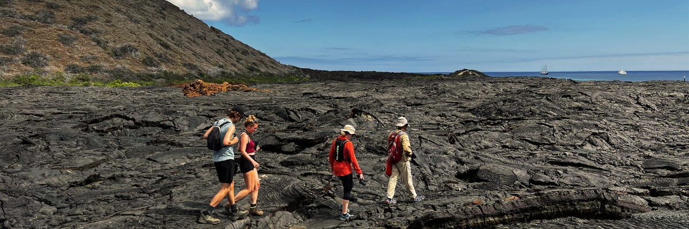
Meals | B / L / D
Trail | 2,2 km / 1,4 mi
Level | 5
Activities | Dry landing and hiking

Day 3 – Monday

AM: SOUTH PLAZAS ISLAND
Begin your day with a visit to South Plazas Island, one of the smaller yet vibrant islands in the Galapagos. This island is renowned for its extraordinary flora, including towering cacti and the striking Sesuvium plant, which changes from green to bright red during the dry season. South Plazas is also home to a large colony of land iguanas, which are often seen lounging under the cacti or wandering around. The steep cliffs on the southern part of the island provide a haven for various seabirds, including swallow-tailed gulls and red-billed tropicbirds. Sea lions frequent the coastline and offers an excellent opportunity to observe their playful antics in the water.
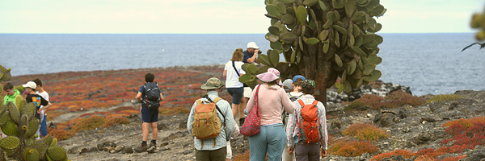
Highlights: Land iguanas, Sesuvium plants, cacti, sea lions, swallow-tailed gulls, red-billed tropicbirds.
Trail | 1 km / 0.6 mi
Level | 2
Activities | Dry landing, hiking

PM: SANTA FE ISLAND
In the afternoon, set off to explore Santa Fe Island, known for its picturesque bay and turquoise waters, perfect for swimming and snorkeling. The island hosts a healthy population of the larger species of land iguanas unique to Santa Fe. Watch for these magnificent creatures as you walk through the giant prickly pear cactus forest. The island's calm, clear waters are ideal for spotting an array of marine life, including sea turtles, rays, and colorful schools of fish. Santa Fe also offers a chance to see the Galapagos hawk and various endemic finches.
This day offers a blend of terrestrial and marine exploration, showcasing the diverse landscapes and wildlife the Galapagos Islands are famous for.
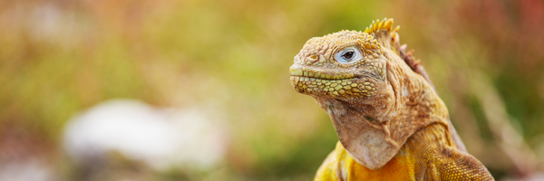
Highlights: Santa Fe land iguanas, prickly pear cactus, sea turtles, Galapagos hawk, snorkeling opportunities.
Trail | 1.5 km / 0.9 mi
Level | 2
Activities | Wet landing, hiking, snorkeling

Day 4 – Tuesday

AM: WITCH HILL
Start your day at Witch Hill, a breathtaking white sand beach on San Cristobal Island's northern coast. This beach is one of the first sites visited by Charles Darwin. It's an exquisite spot for walking and enjoying the scenery, with its powdery white sand and turquoise waters. The area is home to a large sea lion colony, and the nearby lagoon often hosts several bird species, including pelicans and blue-footed boobies. The clear waters also make it an ideal spot for snorkeling, where you can encounter rich marine life.
Beach and Snorkeling Experience: Stroll along the white sands of Witch Hill, enjoy close encounters with sea lions, and explore the vibrant underwater world.
Highlights: White sand beach, sea lions, pelicans, blue-footed boobies, snorkeling opportunities.
Trail | 0.5 km / 0.3 mi
Level | 1
Activities | Wet landing, beach walking, snorkeling

PM: PITT POINT
In the afternoon, head to Pitt Point, located on the eastern end of San Cristobal Island. This unique site is the only place in the Galapagos where you can see all three species of boobies and two species of frigate birds. The trail here offers a challenging hike up a steep path but rewards with stunning views of the coastline. The beach area is also a great spot for snorkeling and swimming, offering a chance to see various marine life.
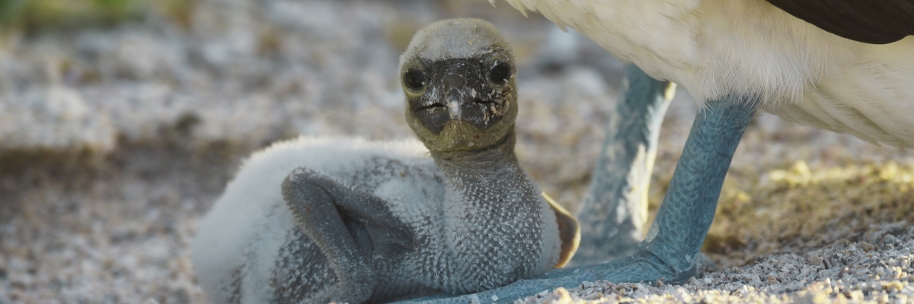
Hiking and Wildlife Observation: Explore the rugged terrain of Punta Pitt and witness the diverse birdlife, including all three booby species and frigate birds.
Highlights: Three booby species (Blue-footed, Red-footed, Nazca), two frigate bird species, stunning views, and snorkeling opportunities.
This day provides a rich experience of San Cristobal Island's diverse landscapes and wildlife, offering both relaxation on a beautiful beach and an adventurous hike with unique wildlife encounters.
Meals | B / L / D
Trail | 1.5 km / 0.9 mi
Level | 3
Activities | Dry landing, hiking, snorkeling

Day 5 – Wednesday

AM: SAN CRISTOBAL HIGHLANDS
Your day begins with a journey to the highlands of San Cristobal Island, offering a different perspective of the Galapagos' unique ecosystem. This lush and verdant area contrasts sharply with the coastal zones. The highlands are home to a variety of bird species, giant tortoises in their natural habitat, and a rich array of plant life, including endemic trees and ferns. You'll have the opportunity to walk along paths that meander through this lush landscape, offering a chance to observe the giant tortoises up close and personal. The highlands also provide panoramic views of the island, showcasing its diverse topography.

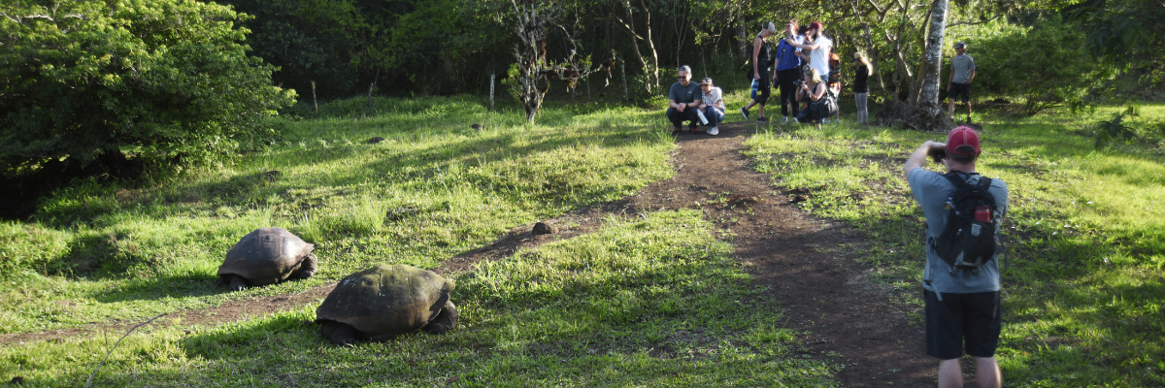
Highlights: Giant tortoises, endemic bird species, panoramic views, lush vegetation.
Meals | B
Trail | Variable
Level | 2
Activities | Dry landing and hiking

PM: LOBOS ISLAND
Venture to Lobos Island, a tranquil islet secluded from San Cristobal by a slim channel. This nature's cradle, amidst a serene bay, is the playground for sea lion pups frolicking in tidal pools. The island might be modest but bursts with life, particularly with "lobos marinos" or sea lions. As you step ashore, welcoming committees of sea lions would greet you, only to be outraged by the male frigatebirds inland, presenting their inflamed red balloons amidst the verdant foliage. Stay vigilant for the blue-footed boobies nesting on the trails, ready to treat you to a display of their whimsical courtship dance.
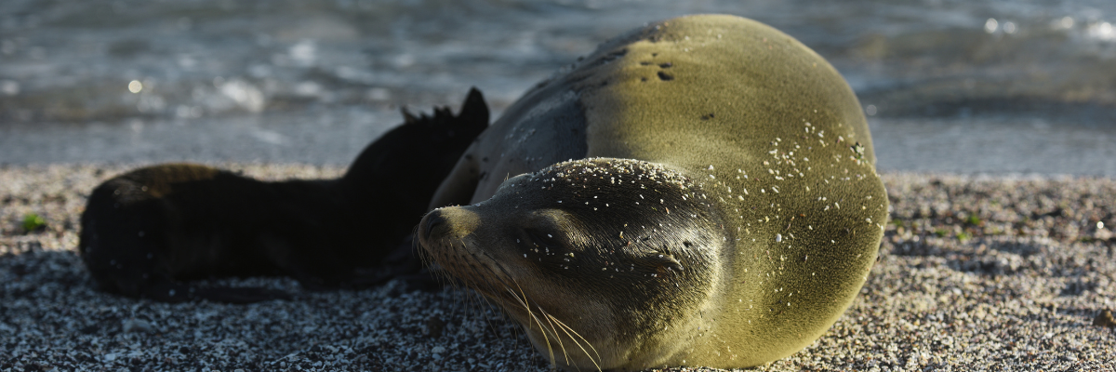
Snorkeling Experience: Dive into an underwater ballet at this renowned snorkeling spot, sheltered by the calm waves. Playful sea lions would eagerly display their acrobatic prowess. In contrast, sea turtles and rays find solace resting on the sandy seabed, giving you a glimpse into the harmonious marine life that thrives beneath the surface.
Highlights: Galapagos sea lions, marine Iguanas, magnificent & great frigatebirds, blue-footed Boobies, and San Cristobal Lava Lizards.
Meals | B/L/D
Trail | 0,6 km / 0,4 mi
Level | 3
Activities | Dry landing and hiking

Day 2 – Thursday

AM: SUAREZ POINT
Embrace the morning at Suarez Point. This rocky trail presents a natural gallery of the Galapagos islands, brimming with an awe-inspiring array of fauna. Upon landing, you'll be greeted by sea lions and marine iguanas, your first hosts in this nature carnival. As you venture further, you'll encounter a mosaic of seabird colonies - from the striking Nazca and blue-footed boobies to the elegant gulls and tropicbirds. The pinnacle of this journey brings you face-to-face with the waved albatross, the island's largest bird (present from April to January). This majestic creature, exclusive to Española, will captivate you with its powerful flight and intricate courtship display.
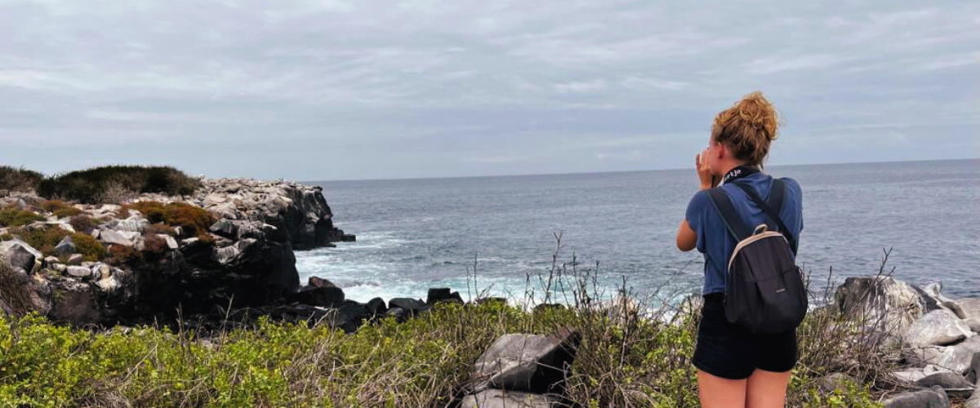
Highlights: Sea lions, Waved Albatross, Galapagos hawks, Española mockingbirds, Darwin finches, marine iguanas, Nazca & Blue-footed Boobies, Red-billed Tropicbirds, Swallow-tailed gulls, herons, lava lizards, herons.
Trail | 1.7 km / 1.1 mi
Level | 3
Activities | Dry landing and hiking

PM: GARDNER BAY
Transition into the afternoon with a thrilling adventure to Gardner Bay, a pristine piece of paradise in the Galapagos archipelago. Sugar-white coral sands merge with crystal-clear turquoise waters, creating a tropical oasis. Watch as the beach becomes a theatre, starring sun-basking sea lions in a playful performance. This idyllic setting invites you to stroll along the coast, immersing yourself in an enlightening experience as you delve into the biology of the endemic fauna - from the melodious Española mockingbird and the unique marine iguanas to the regal Galapagos hawks.
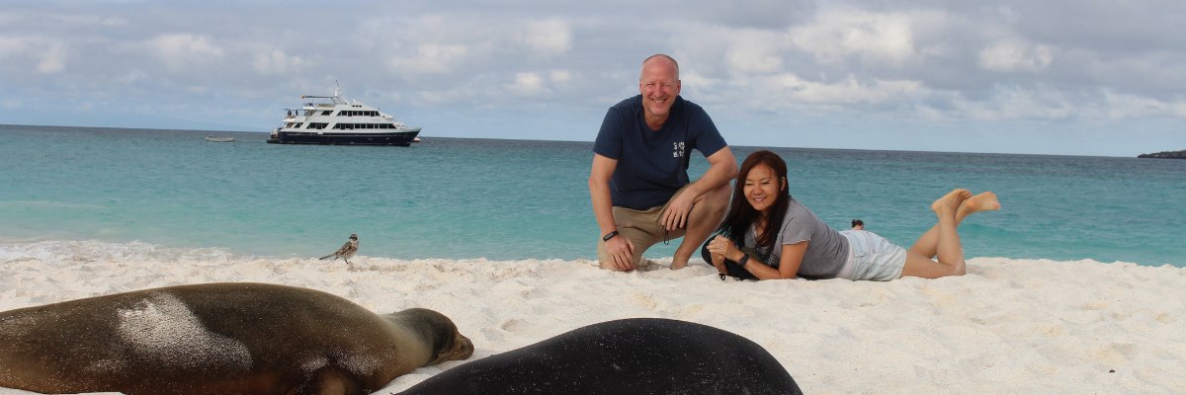
Snorkeling Experience: Submerge beneath the azure waves to witness a spectacular performance choreographed by marine life. Swim alongside playful sea lions, graceful reef sharks, and gliding rays. Discover an array of fish, including vivid Angelfish, charismatic Parrotfish, dynamic Damselfish, and the ever-busy Surgeonfish coloring the underwater landscape.
Highlights: Coral sand beach, sea lions, Galapagos hawks, Española mockingbirds, Darwin finches, marine iguanas.
Meals | B/L/D
Trail | 0,8 km / 0,5 mi
Level | 1
Activities | Wet landing and hiking

Day 3 – Friday

AM: POST OFFICE BAY
Begin your day by stepping into the footprints of the past at Post Office Bay, located on the enigmatic Floreana Island. This locale is imbued with tales from the late 1920s and '30s involving German settlers, a baroness, unsolved mysteries, and captivating intrigue. The bay was a historic anchoring point for whalers, who journeyed to the highlands for freshwater and tortoises. A mail system over two centuries old was established as a hub for visiting vessels centered around a barrel near the beach. This system endures today, offering a unique opportunity to send postcards from this remote part of the world. Apart from its rich history, Post Office Bay presents natural attractions such as a scenic beach, a lava tunnel, and sea tours that can unveil sea lions, green sea turtles, shorebirds, small sharks, and, if luck permits, Galapagos penguins.
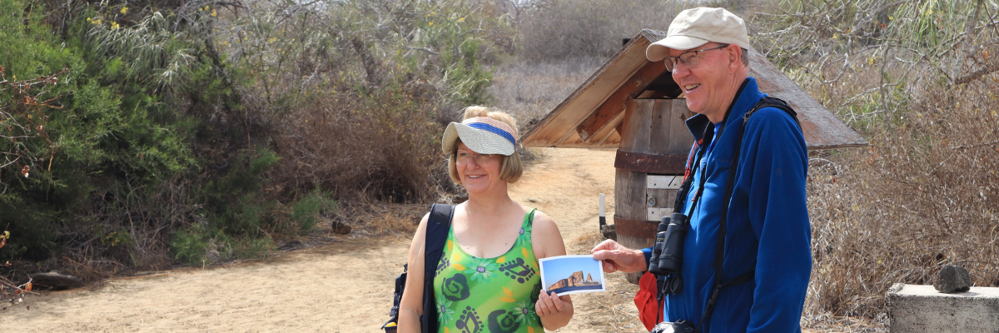
Snorkeling Experience: Delve beneath the waves from the beach, opening up a mesmerizing world of sea turtles, rays, and a diverse plethora of fish. Keep your fingers crossed for a special appearance by the elusive Galapagos penguin.
Highlights: Sea Lions, sea turtles, finches, shorebirds, marine iguanas, and penguins.
Trail | 0,7 km / 0,4 mi
Level | 1
Activities | Wet landing and hiking

PM: CORMORANT POINT
Shift your expedition northwards to Cormorant Point, renowned for its expansive coastal lagoon teeming with American flamingos, white-cheeked pintails, black-necked stilts, and other shorebirds. This natural haven also features a pristine white sand beach, a crucial nesting ground for green sea turtles, and a newly established breeding ground for blue-footed boobies near the trail. Amidst this vibrant wildlife, also take the opportunity to admire the island's unique flora.
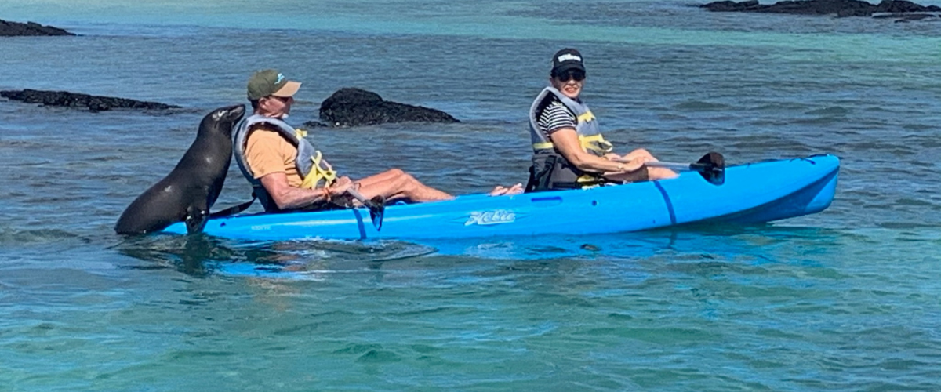
Snorkeling Experience: Snorkeling at Cormorant Point, Floreana, Galapagos, unveils a vibrant underwater world. Visitors swim among tropical fish, rays, sea turtles, and occasionally sea lions beneath crystal-clear waters. The unique olive-green sand beach adds a magical touch to this one-of-a-kind snorkeling experience.
Highlights: American flamingo, blue-footed booby, frigatebirds, tropicbirds, Galapagos shearwaters, sea lions, sea turtle nesting site, finches, shorebirds, coral-sand beach.
Meals | B / L / D
Trail | 1,6 km / 1 mi
Level | 1
Activities | Wet landing and hiking

Day 4 – Saturday

AM: CHARLES DARWIN STATION
Kickstart your day with a profound encounter at the Charles Darwin Station, a dedicated non-profit working hand-in-hand with the Galapagos National Park to safeguard the archipelago's unique biodiversity. This visit provides insights into the collaborative efforts of these institutions to shield native species and combat the invasive ones threatening the delicate balance of the Galapagos ecosystem. One of their emblematic endeavors includes the captive breeding of giant tortoises, an integral part of the conservation strategy. Amidst the educational venture, enjoy the setting of an outdoor native dry forest adorned with towering cacti and a rich array of fascinating endemic flora. This is an ideal spot to discover various endemic Darwin finches, vivacious flycatchers, and melodious mockingbirds.
Highlights: Galapagos giant tortoise & land iguanas breeding program, Darwin finches, Galapagos mockingbirds, Galapagos flycatchers, yellow warblers.

Meals | B/-/-
Level | 1
Activities | Dry landing and hiking

This concludes your unforgettable exploration of the Galapagos Islands, a journey filled with natural wonders and wildlife encounters that will leave a lasting impression and a deeper appreciation for the delicate balance of our planet's ecosystems.

Glossary
Meals | Breakfast | B
 | Lunch | L
 | Dinner | D
Hiking Effort | Level 1 | Easy
 | Level 2 | Moderate
 | Level 3 | Hard

